Name: _____________________________________________ Date: ____________________ Period: __________

APUSH Ch. 1-4 Colonial Map Quiz Study Guide

1. Know the location of continents and specific countries:

* North America, South America, Asia, Europe, Africa
* 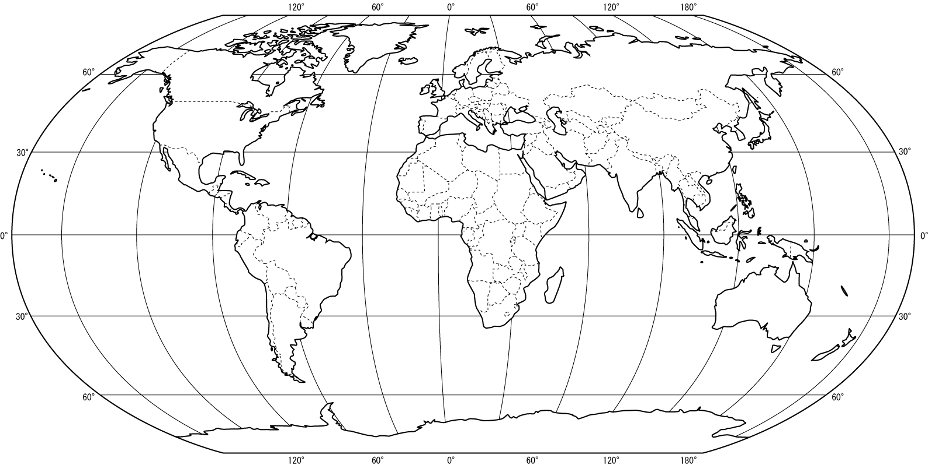India, England, Spain, Portugal, China, West Indies

1. Know the location and region of the 13 British colonies:

* New England: Massachusetts, Connecticut, Rhode Island, New Hampshire
* Middle: New York, Pennsylvania, Delaware
* Southern: Maryland, Virginia, North Carolina, South Carolina, Georgia

1. Know the location of key geographical features:

* Atlantic Ocean, Appalachian Mountains, Great Lakes Region, Delaware Bay, Chesapeake Bay, Hudson River, Potomac River, Delaware River, Susquehanna River, St. Lawrence River, Ohio River, Connecticut River

1. Know the names and locations of key colonial cities:

* Boston, MA; Salem, MA; Newport, RI; Albany, NY; New York, NY; Philadelphia, PA; Jamestown, VA; Charleston, SC; Jamestown, VA

